Assignment 3

Tejas Rode

Agneya A. Kerure

A 3. Resolution is equal to the block size which is 1024. Yes, the resolution can be increased by increasing the size of the FFT.

D 1. When there is an instantaneous change in the frequency, myPitchTrackMax() fails as it has trouble dealing with quick pitch changes. HPS fails as it requires harmonics to be present. The generated sine wave does not contain any harmonics and thus the product becomes 0.

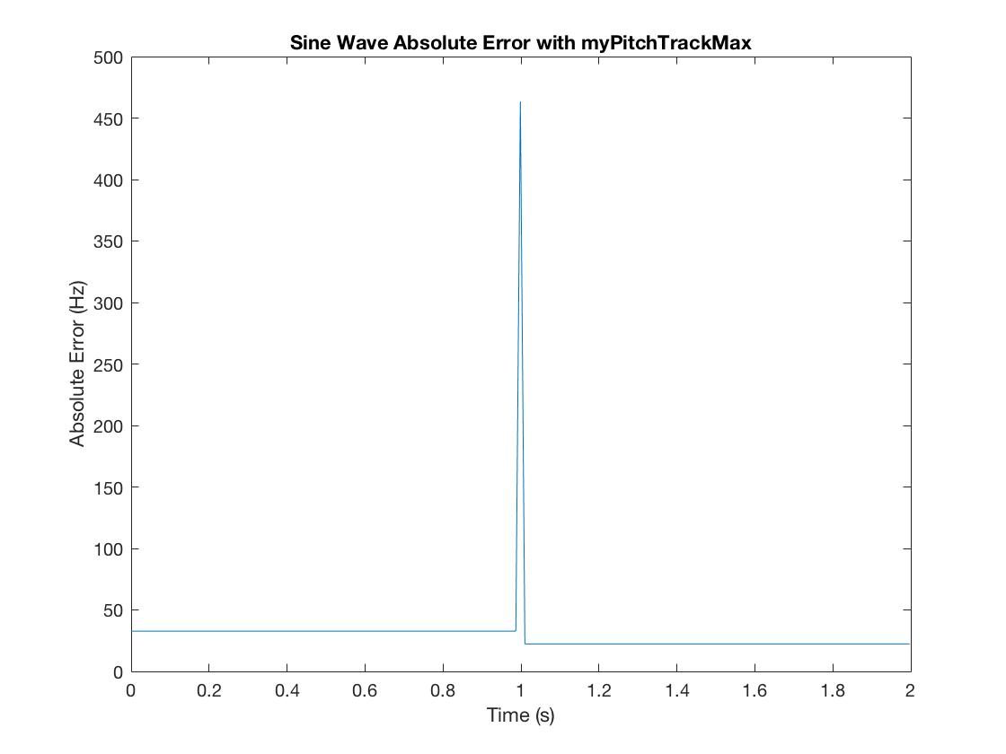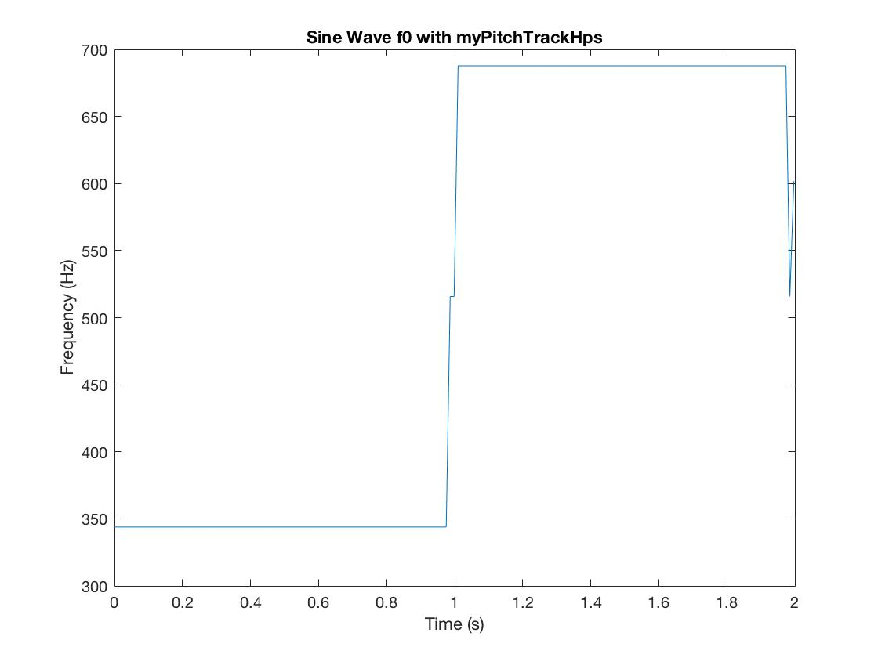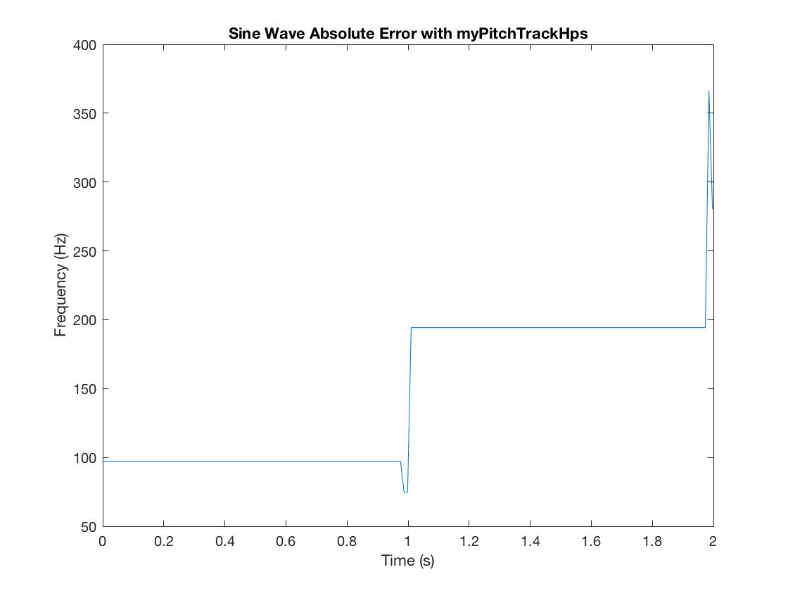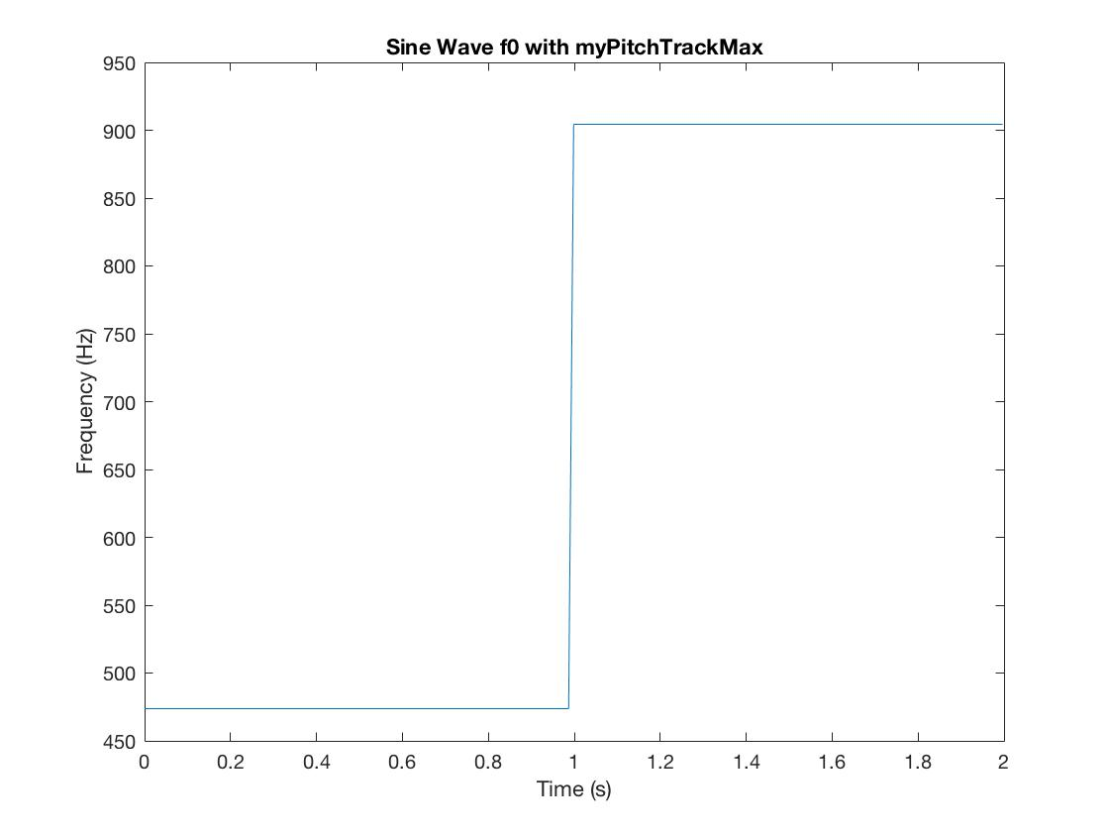

D 2. blockSize = 2048, hopSize = 512

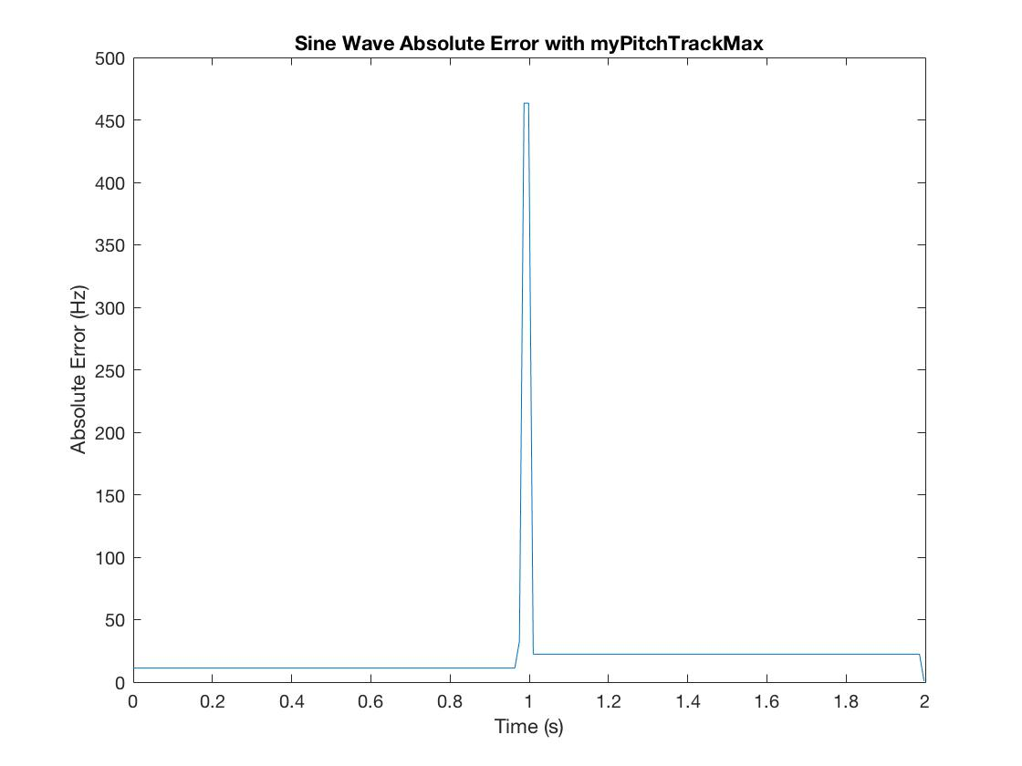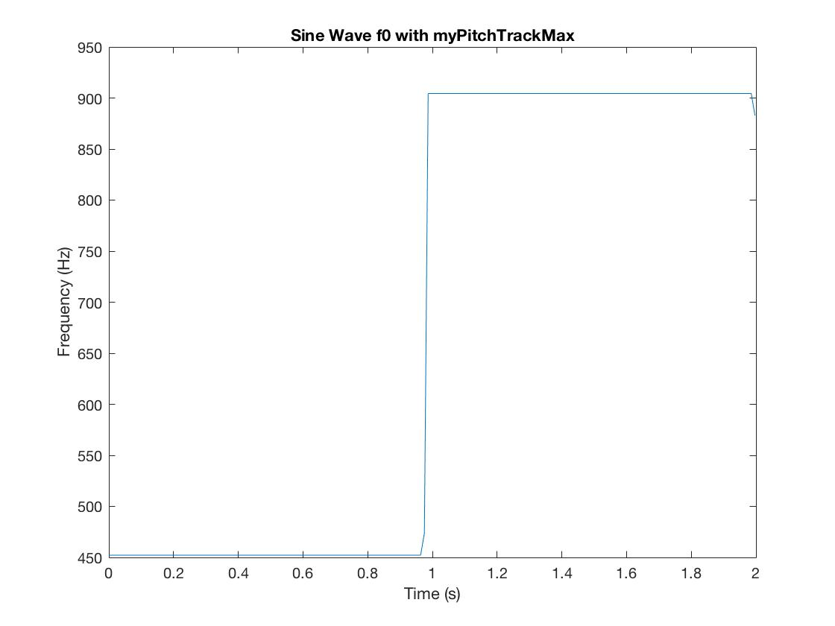

There is marginal improvement when the blockSize is increased. The error is reduced.

E 4.

myPitchTrackMax - -40 - RMS PFP PFN

Audio File 1

ans =

38.7309 0 100.0000

Audio File 2

ans =

142.4600 0 100.0000

Audio File 3

ans =

138.5078 0 100.0000

myPitchTrackHps - -40 - RMS PFP PFN

Audio File 1

ans =

233.0991 0 100.0000

Audio File 2

ans =

96.3731 0 100.0000

Audio File 3

ans =

110.3395 0 100.0000

myPitchTrackAcf - -40 - RMS PFP PFN

Audio File 1

ans =

201.4526 58.9718 0

Audio File 2

ans =

267.3705 74.7191 0

Audio File 3

ans =

204.2412 38.1180 0

myPitchTrackMax - -40 - RMS PFP PFN

Audio File 1

ans =

201.4526 58.9718 0

Audio File 2

ans =

267.3705 74.7191 0

Audio File 3

ans =

204.2412 38.1180 0

myPitchTrackHps - -40 - RMS PFP PFN

Audio File 1

ans =

201.4526 58.9718 0

Audio File 2

ans =

267.3705 74.7191 0

Audio File 3

ans =

204.2412 38.1180 0

myPitchTrackAcf - -20 - RMS PFP PFN

Audio File 1

ans =

201.4526 100.0000 0

Audio File 2

ans =

267.3705 100.0000 0

Audio File 3

ans =

204.2412 100.0000 0

myPitchTrackMax - -20 - RMS PFP PFN

Audio File 1

ans =

201.4526 100.0000 0

Audio File 2

ans =

267.3705 100.0000 0

Audio File 3

ans =

204.2412 100.0000 0

myPitchTrackHps - -20 - RMS PFP PFN

Audio File 1

ans =

201.4526 100.0000 0

Audio File 2

ans =

267.3705 100.0000 0

Audio File 3

ans =

204.2412 100.0000 0